Lab - Observing DNS Resolution (Instructor Version)

**Instructor Note**: Red font color or gray highlights indicate text that appears in the instructor copy only.

1. Objectives

Part 1: Observe the DNS Conversion of a URL to an IP Address

Part 2: Observe DNS Lookup Using the nslookup Command on a Web Site

Part 3: Observe DNS Lookup Using the nslookup Command on Mail Servers

1. Background / Scenario

The Domain Name System (DNS) is invoked when you type a Uniform Resource Locator (URL), such as <http://www.cisco.com>, into a web browser. The first part of the URL describes which protocol is used. Common protocols are Hypertext Transfer Protocol (HTTP), Hypertext Transfer Protocol over Secure Socket Layer (HTTPS), and File Transfer Protocol (FTP).

DNS uses the second part of the URL, which in this example is www.cisco.com. DNS translates the domain name (www.cisco.com) to an IP address to allow the source host to reach the destination host. In this lab, you will observe DNS in action and use the **nslookup** (name server lookup) command to obtain additional DNS information. Work with a partner to complete this lab.

1. Required Resources

1 PC (Windows 7 or 8 with Internet and command prompt access)

1. Observe the DNS Conversion of a URL to an IP Address
   * 1. Click the **Windows Start** button, type **cmd** into the search field,and press Enter. The command prompt window appears.
     2. At the command prompt, ping the URL for the Internet Corporation for Assigned Names and Numbers (ICANN) at **www.icann.org**. ICANN coordinates the DNS, IP addresses, top-level domain name system management, and root server system management functions. The computer must translate www.icann.org into an IP address to know where to send the Internet Control Message Protocol (ICMP) packets.

The first line of the output displays www.icann.org converted to an IP address by DNS. You should be able to see the effect of DNS, even if your institution has a firewall that prevents pinging, or if the destination server has prevented you from pinging its web server.

**Note**: If the domain name is resolved to an IPv6 address, use the command **ping -4 www.icann.org** to translate into an IPv4 address if desired.

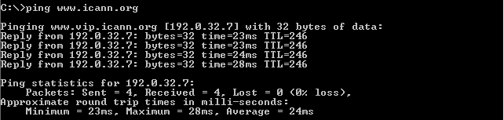

Record the IP address of www.icann.org. __________________________________ 192.0.32.7

* + 1. Type the IP address from **step b** into a web browser, instead of the URL. Click **Continue to this website (not recommended).** to proceed.

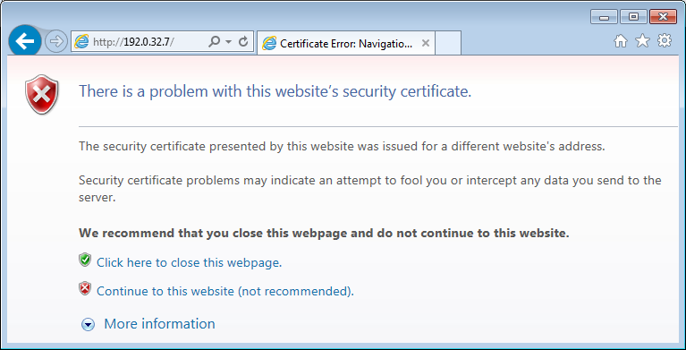

* + 1. Notice that the ICANN home web page is displayed.

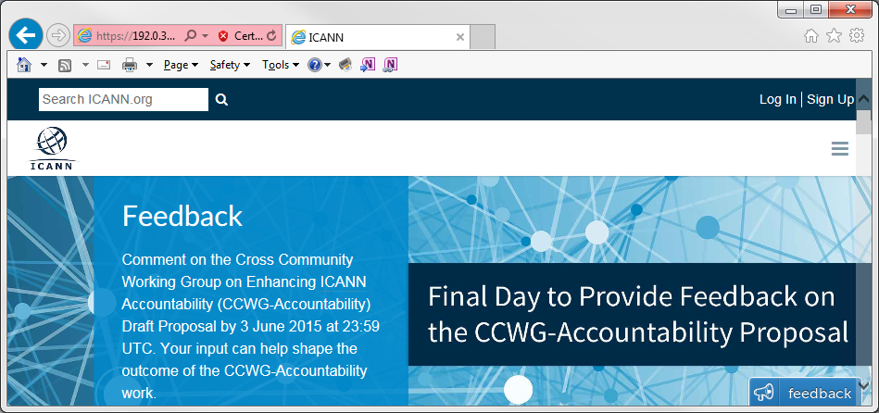

Most humans find it easier to remember words, rather than numbers. If you tell someone to go to **www.icann.org**, they can probably remember that. If you told them to go to 192.0.32.7, they would have a difficult time remembering an IP address. Computers process in numbers. DNS is the process of translating words into numbers. There is a second translation that takes place. Humans think in Base 10 numbers. Computers process in Base 2 numbers. The Base 10 IP address 192.0.32.7 in Base 2 numbers is 11000000.00000000.00100000.00000111. What happens if you cut and paste these Base 2 numbers into a browser?

____________________________________________________________________________________

____________________________________________________________________________________

____________________________________________________________________________________

The web site does not display. The software code used in web browsers recognizes Base 10 numbers. It does not recognize Base 2 numbers.

* + 1. Now type **ping** [**www.cisco.com**](http://www.cisco.com).

**Note**: If the domain name is resolved to an IPv6 address, use the command **ping -4 www.cisco.com** to translate into an IPv4 address if desired.

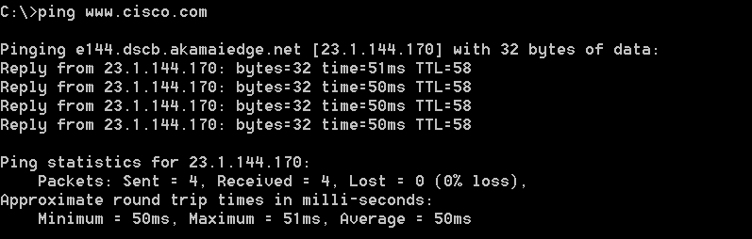

* + 1. When you ping www.cisco.com, do you get the same IP address as the example? Explain.

____________________________________________________________________________________

____________________________________________________________________________________

____________________________________________________________________________________

Answer will vary depending upon where you are geographically. Cisco hosts its web content on a series of mirror servers. This means that Cisco uploads the exact same content to geographically diverse (spread out all over the world) servers. When someone tries to reach [www.cisco.com](http://www.cisco.com), the traffic is directed to the closest mirror server.

* + 1. Type the IP address that you obtained when you pinged www.cisco.com into a browser. Does the web site display? Explain.

____________________________________________________________________________________

____________________________________________________________________________________

____________________________________________________________________________________

The **cisco.com** web site does not display. There are at least two possible explanations for this: 1. Some web servers are configured to accept IP addresses sent from a browser and some are not. 2. It may be a firewall rule in the Cisco security system that prohibits an IP address from being sent via a browser.

1. Observe DNS Lookup Using the nslookup Command on a Web Site
   * 1. At the command prompt, type the **nslookup** command.

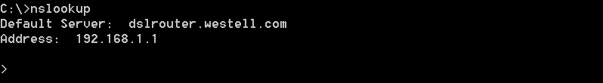

What is the default DNS server used? _________________________________________

Site dependent

Notice how the command prompt changed to a greater than (>) symbol. This is the **nslookup** prompt. From this prompt, you can enter commands related to DNS.

At the prompt, type **?** to see a list of all the available commands that you can use in **nslookup** mode.

* + 1. At the prompt, type **www.cisco.com**.

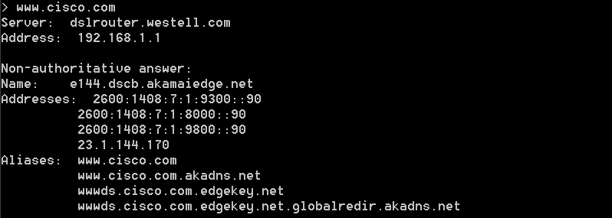

What is the translated IP address? ________________________________________________

From a specific location, 23.1.144.170.

**Note**: The IP address from your location will most likely be different because Cisco uses mirrored servers in various locations around the world.

Is it the same as the IP address shown with the **ping** command? _________________ Yes

Under addresses, in addition to the 23.1.144.170 IP address, there are the following numbers: 2600:1408:7:1:9300::90, 2600:1408:7:1:8000::90, 2600:1408:7:1:9800::90. What are these?

____________________________________________________________________________________

IPv6 (IP version 6) IP addresses at which the web site is reachable.

* + 1. At the prompt, type the IP address of the Cisco web server that you just found. You can use **nslookup** to get the domain name of an IP address if you do not know the URL.

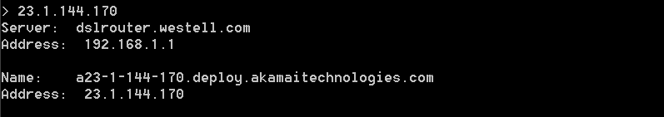

You can use the **nslookup** tool to translate domain names into IP addresses. You can also use it to translate IP addresses into domain names.

Using the **nslookup** tool, record the IP addresses associated with [www.google.com](http://www.google.com).

____________________________________________________________________________________

Answers may vary. At the time of writing, the IP addresses are 173.194.75.147, 173.194.75.105, 173.194.75.99, 173.194.75.103, 173.194.75.106, and 173.194.75.104.

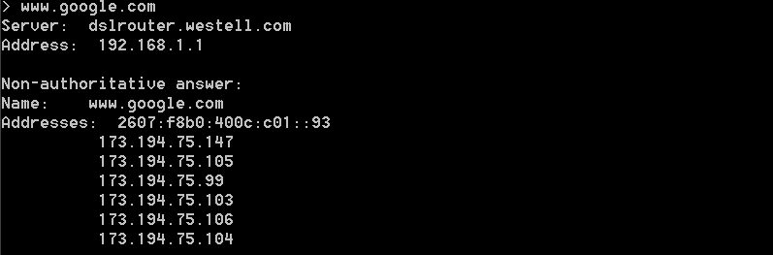

1. Observe DNS Lookup Using the nslookup Command on Mail Servers
   * 1. At the prompt, type **set type=mx** to use **nslookup** to identify mail servers.

set type mx

* + 1. At the prompt, type **cisco.com**.

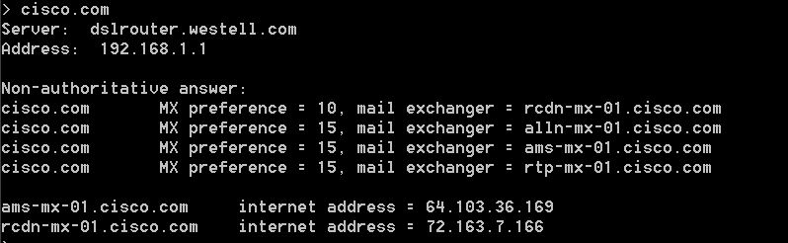

A fundamental principle of network design is redundancy (more than one mail server is configured). In this way, if one of the mail servers is unreachable, then the computer making the query tries the second mail server. Email administrators determine which mail server is contacted first by using **MX preference** (see above image). The mail server with the lowest **MX preference** is contacted first. Based upon the output above, which mail server will be contacted first when the email is sent to cisco.com?

____________________________________________________________________________________

rcdn-mx-01.cisco.com

* + 1. At the nslookup prompt, type **exit** to return to the regular PC command prompt.
    2. At the PC command prompt, type **ipconfig /all**.
    3. Write the IP addresses of all the DNS servers that your school uses.

____________________________________________________________________________________

Site-dependent

1. Reflection

What is the fundamental purpose of DNS?

_______________________________________________________________________________________

_______________________________________________________________________________________

_______________________________________________________________________________________

People process in words. Computers process in numbers. People have a difficult time remembering a long string of numbers. Therefore, DNS exists to translate the “numbers” world of computers to the “words” world of people.